TONBAGFEEDINGSTATION
The ton bag feeding station, also known as the ton bag unpacking station or bulk bag discharging station, is an
automated or semi-automated device designed for safely and efficiently unloading powdered or granular materials
from ton bags. It is widely used in industries such as chemical, food, pharmaceutical, building materials, plastics,
and agriculture, suitable for discharging materials with good or poor flowability. Additionally, it can be integrated
with auxiliary systems like dust removal, screening, and conveying to achieve dust-free and automated
production
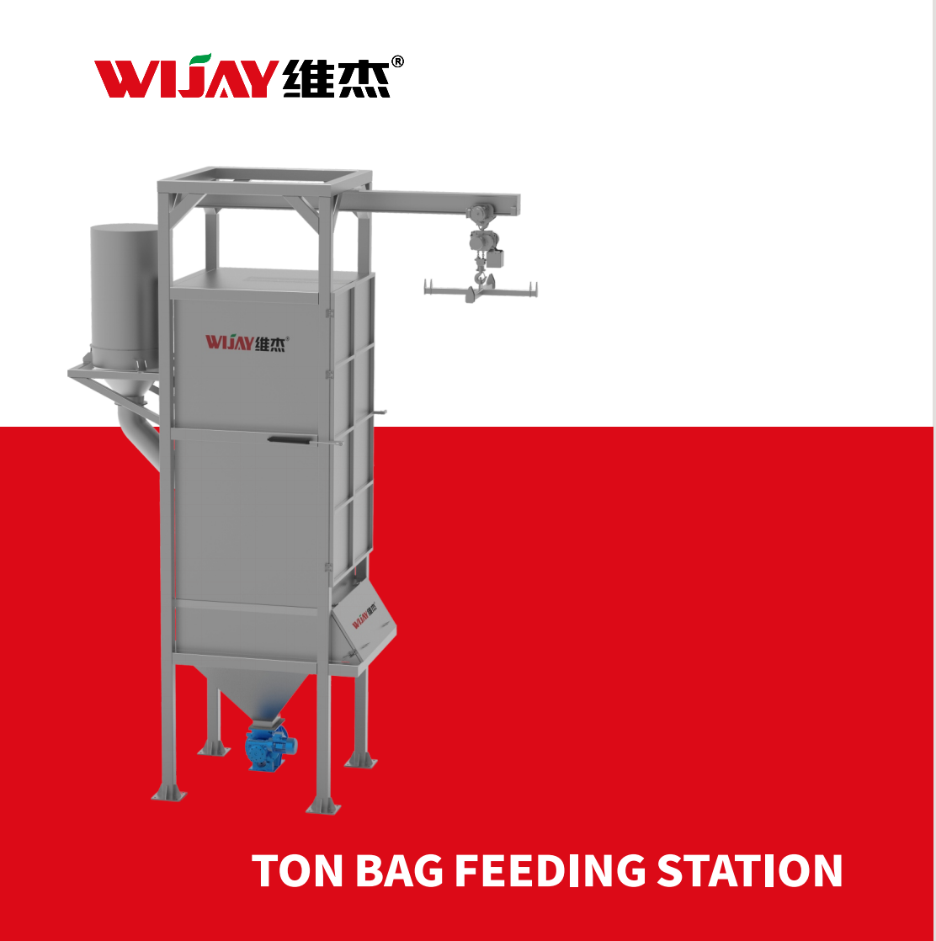
Product Advantages
1. High-Efficiency Production Advantage: Fast unloading speed, reduced reliance on manual labor, seamlessintegration with production lines.
Safety & Environmental Advantage: Excellent dust control, explosion-proof safety design, reduced occupational
hazards
Material Adaptability Advantage: Broad material compatibility, complete unloading guarantee, special material
handling.
Economic Advantage: Long-term cost savings, easy maintenance, high space utilization.
Intelligent Development Advantage: Automated integration, traceable data, intelligent monitoring.
Smart Management: Data recording, networked monitoring, traceability support.
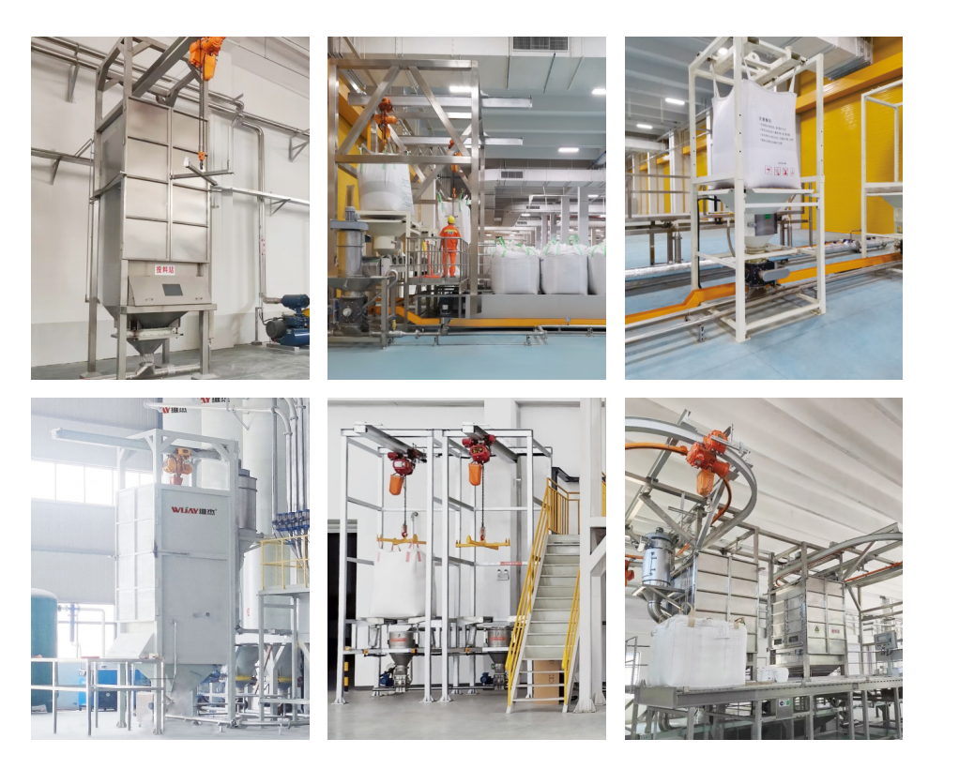
Bulk Bag Unloading Stations are classified into the following 4 grades based on throughput capacity
- Single-Station Bulk Bag Unloading Station (Capacity: 2-10 TPH)
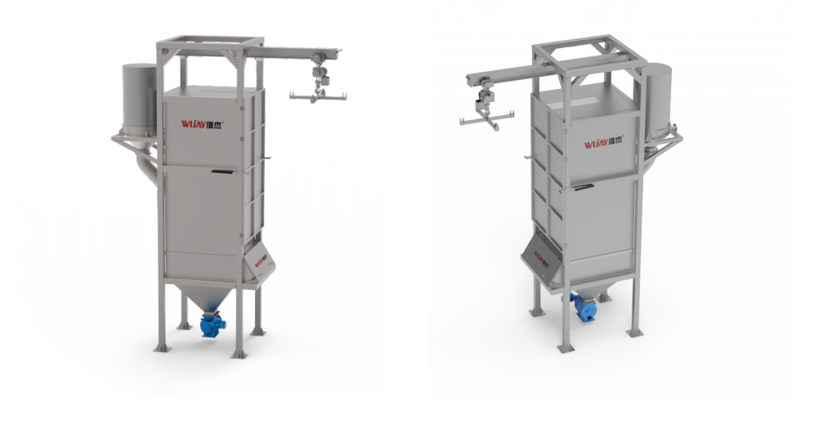
- Dual-Station Bulk Bag Unloading Station (Capacity: 10-20 T/H)
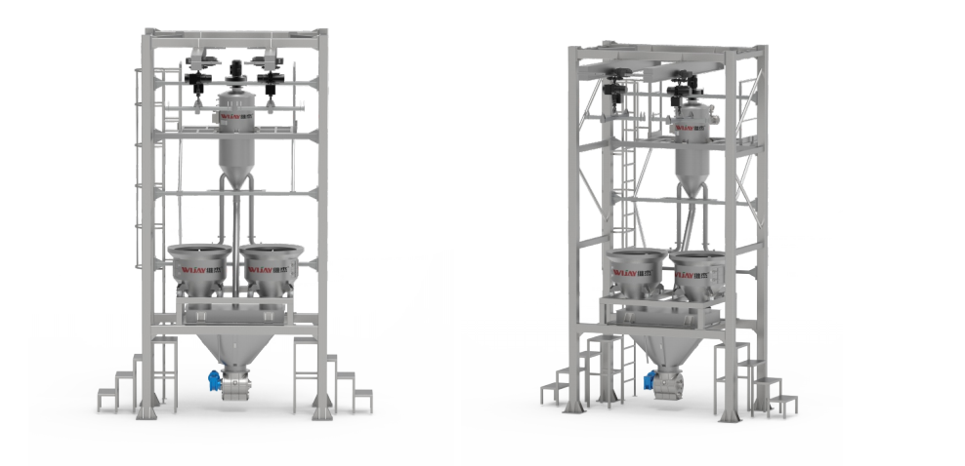
- Continuous Circular-Rail Bulk Bag Unloading System (Capacity: 20-40 T/H)
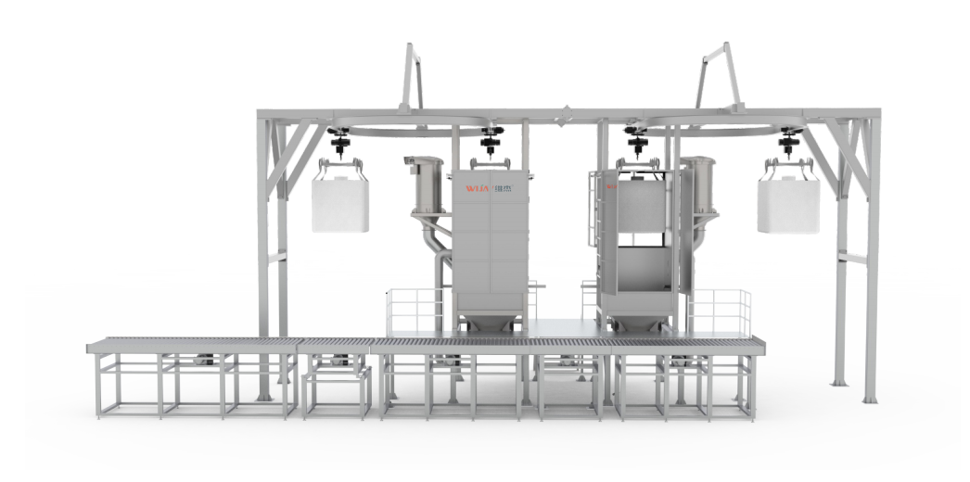
- Continuous Linear-Rail Bulk Bag Unloading System (Capacity: >40 T/H)
